NEED TO KNOW COLUMN

Elder Sign-up Sheet for the second half of the year has
been posted in the hall by Rev. Doughton’s Office.
Please sign-up today!
GUIDE TO WORSHIP
July 26, 2026
8:45 a.m. & 11:00 a.m.

Cover Picture
This is a view of the Damascus Gate in Jerusalem. Paul left the city through an earlier version of this gate to reach Damascus. However, a funny thing happened along the way.
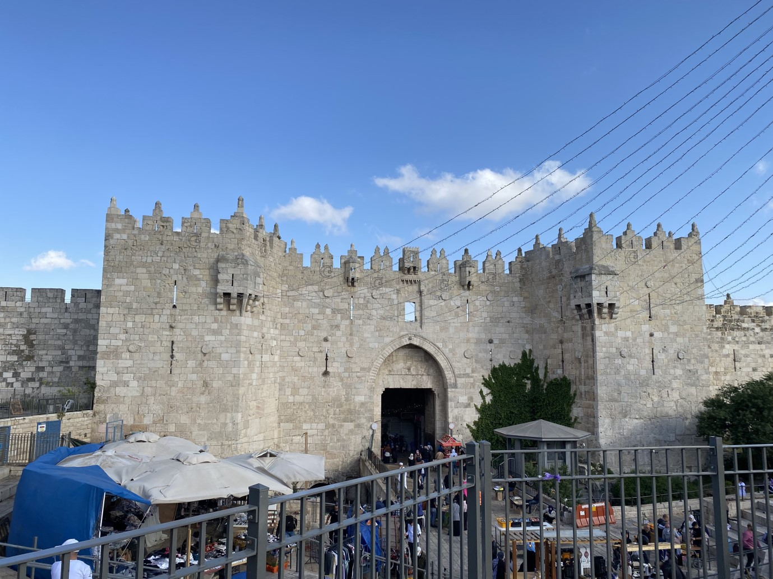
ONLINE GIVING OPTION
Have you ever thought of giving online?
If you would like to give online you may scan the QR Code, this will take you to the
giving button on our website.
FIRST PRESBYTERIAN CHURCH
1028 South Belt Line rd Mesquite, Texas 75149
972-285-5602
www.fpcmesquite.org

Saturday, July 25 to Monday, August 3
Rev. Doughton will be away on a family vacation
Sunday, July 26 - Guest Preacher, Rev. Craig Krueger
7:30 a.m. - Men’s Council Breakfast - Craig Krueger is the Guest Speaker 8:45 a.m. and 11:00 a.m. Worship Service

9:45 a.m. - Sunday School for all ages

Sunday, August 9, 2026
Sunday, August 2 - Guest Preacher, Rev. Josh Maddin
The Lord’s Supper will be observed at both Worship Services
8:45 a.m. and 11:00 a.m. Worship Service 9:45 a.m. - Sunday School for all ages
Wednesday, August 5
5:00 p.m. - Staff Meeting
7:00 p.m. - Chancel Choir Rehearsal
Sunday, August 9 - Blessing of the Backpacks @ 11:00
8:45 a.m. and 11:00 a.m. Worship Service 9:45 a.m. - Sunday School for all ages
Monday, August 10
7:15 p.m. - Evaluation, Strategy, and Planning Committee will meet in the Crossroads Classroom
Tuesday, August 11
7:00 p.m. - Christian Education Committee Mtg. - Crossroads Classroom 7:30 p.m. - Worship Committee Meeting in Sr. High Classroom
Wednesday, August 12
7:00 p.m. - Chancel Choir Rehearsal


Sunday, August 16 Rally Day

SUNDAY, AUGUST 16, 2026
8:45 a.m. and 11:00 a.m. Worship Service 9:45 a.m. - Sunday School for all ages
12:00 p.m. - Indoor Picnic in Wilbanks Hall
Tuesday, August 18
7:15 p.m. - Joint Officers Stated Meeting in Genesis Classroom
Wednesday, August 19
7:00 p.m. - Chancel Choir Rehearsal
Sunday, August 23
7:30 a.m. - Men’s Council Breakfast - Youth from Mission Trip (speakers) 8:45 a.m. and 11:00 a.m. Worship Service
9:45 a.m. - Sunday School for all ages

Tuesday, August 25
6:30 p.m. - Presbyterian Women Kick-off Dinner for 2026-2027
Wednesday, August 26
7:00 p.m. - Chancel Choir Rehearsal

Sunday, August 30
The challenge
The 100 Can Challenge continues . . .
Let us carry on THE CHALLENGE to collect can goods and other non-perishable items. The donated items will be given to Sharing Life, as they feed those in need in
our community. Our total collected thus far in July is 97
items. Thank You!
8:45 a.m. and 11:00 a.m. Worship Service 9:45 a.m. - Sunday School for all ages

THOSE WHO SERVE
Rev. Dr. E. Jones Doughton, Pastor
Ryoji Shimpo, Director of Music Ministries/Organist & Pianist Renee Stormer, Administrative Assistant
Rev. Dr. Thomas G. Wilbanks, Pastor Emeritus

SERVICE FOR THE LORD’S DAY

STRIKING OF THE HOUR FOR WORSHIP
PRELUDE ?? arr. Becki Slagle Mayo
INTROIT 627 I Love You, Lord Laurie Klein I love You, Lord, and I lift my voice to worship You;
O my soul, rejoice.
Take joy, my King, in what You hear; may it be a sweet, sweet sound in Your ear.

CALL TO WORSHIP Philippians 1:2
Grace to you, and peace, from God our Father and the Lord Jesus Christ.

And also, to you.
As the deer pants for the water, so do our hearts long after You; You alone are our souls desire and we long to worship You. Let us worship God.

*HYMN 15 All Creatures of Our God and King
*CALL TO CONFESSION
*PRAYER OF CONFESSION

Mighty and Merciful God, by Your power Christ is raised from Death to rule this world in love. We confess that we have not believed in Him but fall into doubt and fear. Gladness has no home in our hearts, and gratitude is slight. Forgive our hopelessness and set us free for joy in the victory of Jesus Christ, Who was dead but lives, and will put down every power to hurt or destroy, when Your promised kingdom comes. Amen.

*ASSURANCE OF FORGIVENESS
*RESPONSE (Hymn 581)

Glory be to the Father, and to the Son, and to the Holy Ghost; As it was in the beginning, is now, and ever shall be,
world without end. A—men. A—men.

WELCOME AND ANNOUNCEMENTS #
ANTHEM (11:00) ?? P.P. Bilhorn
Chancel Choir arr. Stan Pethel
I’ve cast my heavy burdens down on Canaan’s happy shore;
I’m living where the healing waters flow.
I’ll wander in the wilderness of doubt and sin no more; I’m living where the healing waters flow.
Refrain: Living on the shore, I’m living on the shore, I’m living where the healing waters flow.
Living on the shore, I’m living on the shore, I’m living where the healing waters flow.
(continued)
With Israel’s trusting children, I’m rejoicing on my way;
I’m living where the healing waters flow.
The cloudy, fiery pillar is my guiding light today; I’m living where the healing waters flow. [Refrain]
I’m singing, “Hallelujah;” safely anchored is my soul; I’m living where the healing waters flow.
I’m resting on His promises, His blood has made me whole; I’m living where the healing waters flow. [Refrain]

PRAYER FOR ILLUMINATION #
Gracious and All-Knowing God give us ears to hear, minds to understand, feet to act as we hear Your word read and preached in Jesus Name. Amen.
FIRST SCRIPTURE LESSON # Psalm 105:1-11
O give thanks to the Lord, call on His name, make known His deeds among the peoples. Sing to Him, sing praises to Him; tell of all His wonderful works. Glory in His holy name; let the hearts of those who seek the Lord rejoice. Seek the Lord and His strength; seek his presence continually. Remember the wonderful works He has done, His miracles, and the judgments He has uttered, O offspring of His servant Abraham, children of Jacob, His chosen ones. He is the Lord our God; His judgments are in all the earth. He is mindful of His covenant forever, of the word that He commanded, for a thousand generations, the covenant that He made with Abraham, His sworn promise to Isaac, which He confirmed to Jacob as a statute, to Israel as an everlasting covenant, saying, "To you I will give the land of Canaan as your portion for an inheritance."
SECOND SCRIPTURE LESSON # Romans 8:26-39
Likewise the Spirit helps us in our weakness; for we do not know how to pray as we ought, but that very Spirit intercedes with sighs too deep for words. And God, Who searches the heart, knows what is the mind of the Spirit, because the Spirit intercedes for the saints according to the will of God. We know that all things work together for good for those who love God, who are called according to His purpose. For those whom He foreknew He also predestined to be conformed to the image of His Son, in order that He might be the firstborn within a large family. And those whom He predestined He also called; and those whom He called He also justified; and those whom He justified He also glorified. What then are we to say about these things? If God is for us, who is against us? He Who did not withhold His own Son, but gave Him up for all of us, will He not with Him also give us everything else? Who will bring any charge against God's elect? It is God Who justifies. Who is to condemn? It is Christ Jesus, Who died, yes, Who was raised, Who is at the right hand of God, Who indeed intercedes for us. Who will separate us from the love of Christ? Will hardship, or distress, or persecution, or famine, or nakedness, or peril, or sword? As it is written, "For your sake we are being killed all day long; we are accounted as sheep to be slaughtered." No, in all these things we are more than conquerors through Him who loved us. For I am convinced that neither death, nor life, nor angels, nor rulers, nor things present, nor things to come, nor powers, nor height, nor depth, nor anything else in all creation, will be able to separate us from the love of God in Christ Jesus our Lord.
The Word of the Lord.

Thanks be to God.
MOMENT FOR YOUNG DISCIPLES (11:00)
The Children and Youth are asked to come forward at this time.
*HYMN 463 How Firm a Foundation
SERMON What Shall We Say Rev. Craig Krueger
*AFFIRMATION OF FAITH Apostles’ Creed
I believe in God, the Father Almighty, Maker of heaven and earth; And in Jesus Christ, His only Son, our Lord; Who was conceived by the Holy Ghost, born of the Virgin Mary, suffered under Pontius Pilate, was crucified, dead, and buried; He descended into hell; the third day He rose again from the dead; He ascended into heaven, and sitteth on the right hand of God the Father Almighty; from thence He shall come to judge the quick and the dead. I believe in the Holy Ghost; the holy catholic church; the communion of saints; the forgiveness of sins; the resurrection of the body; and the life everlasting. Amen.
PASTORAL PRAYER
THE LORD’S PRAYER

Our Father, Who art in heaven, Hallowed be Thy name. Thy kingdom come, Thy will be done, on earth as it is in heaven. Give us this day our daily bread; and forgive us our debts, as we forgive our debtors; and lead us not into temptation, but deliver us from evil. For Thine is the kingdom and the power and the glory, forever. Amen.

INVITATION TO THE OFFERING PRESENTATION OF TITHES AND OFFERINGS
OFFERTORY ?? arr. Lloyd Larson Ryoji Shimpo, pianist
*DOXOLOGY (Hymn 606)

Praise God from whom all blessings flow; Praise Him, all creatures here below; Praise Him above, ye heavenly host:
Praise Father, Son, and Holy Ghost. Amen.

*PRAYER OF DEDICATION †
*HYMN 39 Great Is Thy Faithfulness

*CHARGE AND BENEDICTION
*RESPONSE 546 (v.1) Lord, Dismiss Us with Your Blessings
Sicilian melody
Lord, dismiss us with Your blessing;
fill our hearts with joy and peace;
let us each, Your love possessing, triumph in redeeming grace.
O refresh us, O refresh us, traveling through this wilderness.
POSTLUDE ?? arr. Hugh S. Livingston, Jr.
Please be seated as the Postlude begins.

ASSISTING IN WORSHIP
Elder # - Dr. Carol Stephenson (8:45); Ann Smith (11:00)
Deacon/Ushers † - Dallas Ward, Sharon Condarco,
and Nick Scholl (8:45);
Dallas Ward, Sharon Condarco, Nick Scholl, and Linda Fricke (11:00)

